Design Thinking Framework
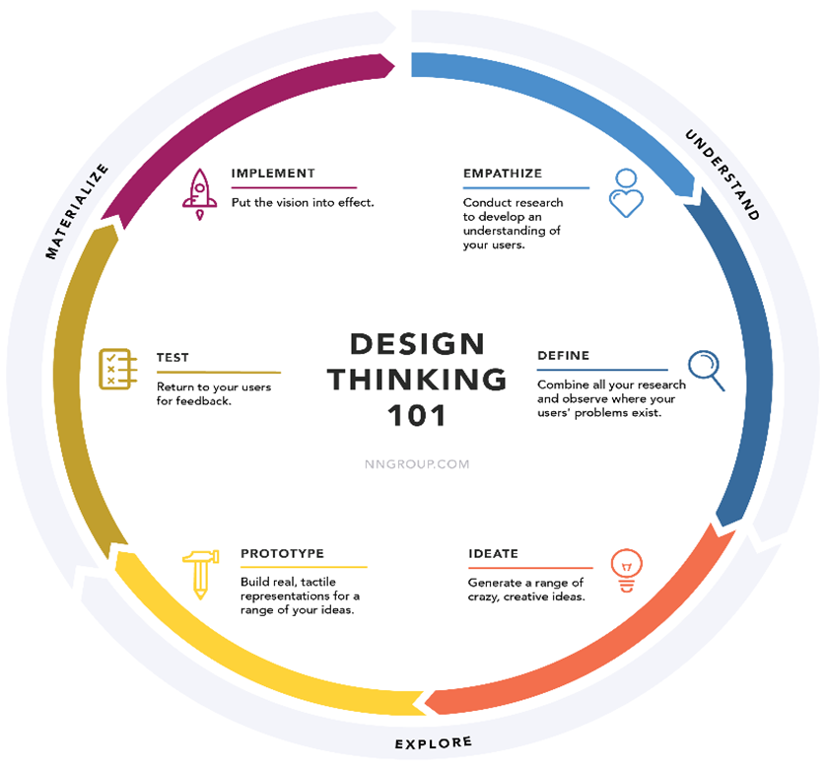

https://www.nngroup.com

Design Thinking Framework

Empathize-Conduct research to develop an understanding of users.

Define-combine all your research and observe where your users problems exist.

Ideate-generate a range of crazy, creative ideads.

Prototype-build ral, tactle, representations for a range of your ideas.

Test-return to your users for feedback

implement-put the vision into effect

